**Key strengths and weaknesses of the speculated contenders for the Presidential elections come 2027 to enhance Voter’s considerations**

Below is a critical brief on the major contenders for the 2027 Nigerian presidential election, focusing on Bola Ahmed Tinubu, Goodluck Jonathan, Atiku Abubakar, Peter Obi, Rabiu Musa Kwankwaso, Seyi Makinde, and Rotimi Amaechi. Each contender’s strengths and weaknesses are analyzed based on their political experience, regional influence, public perception, and challenges, grounded in the current political landscape and insights from various sources. The analysis also considers Nigeria’s electoral dynamics, including regional voting patterns (e.g., APC’s North-West dominance, LP’s South-East strength in 2023) and the low voter turnout (27% in 2023).

**1. Bola Ahmed Tinubu (APC)Profile:**

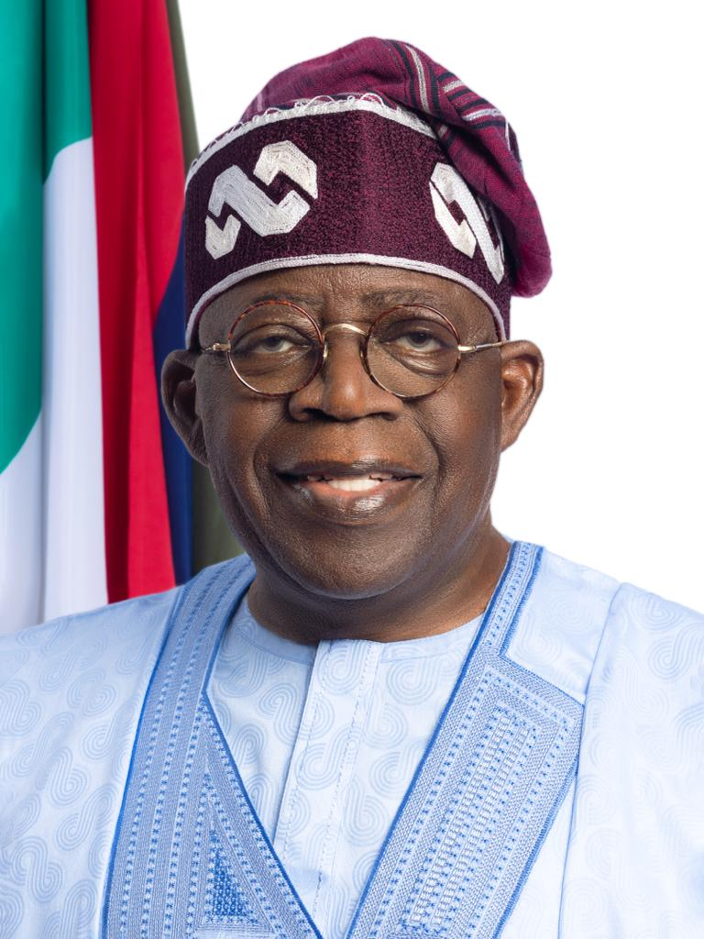

Incumbent President (2023–present), former Lagos Governor (1999–2007), and APC national leader. Known as the “Jagaban,” Tinubu won the 2023 election with 8.79 million votes (36.61%).

**Strengths**

**• Incumbency Advantage:** As the sitting president, Tinubu controls federal resources, patronage networks, and the APC’s national structure, which dominates the North-West and South-West. His administration’s reforms (e.g., fuel subsidy removal, digital economy initiatives) are touted as long-term gains by supporters.

• **Political Network:** Tinubu’s extensive alliances, built over decades, include loyalists like Kano Governor Abdullahi Ganduje, giving him a strong foothold in key voting regions. His financial war chest and campaign experience are unmatched, as seen in his 2023 primary victory.

• **South-West Dominance:** His Yoruba base and control of Lagos ensure a solid regional vote, with the APC’s infrastructure amplifying his reach.

**Weaknesses:**

**• Economic Backlash:** Tinubu’s policies, like fuel subsidy removal and naira devaluation, have fueled inflation and hardship, alienating voters. A 2025 survey showed 90% distrust in political leaders, with Tinubu’s ethnic-focused appointments deepening regional grievances.

• **Eroding Northern Support:** His 2023 northern coalition is fraying due to unfulfilled promises and security challenges (e.g., banditry, kidnapping), weakening his North-West and North-East base.

• **Health and Age Concerns:** At 75 by 2027, Tinubu’s age and perceived health issues may deter voters seeking a younger, dynamic leader.

**2. Goodluck Jonathan (PDP)Profile:**

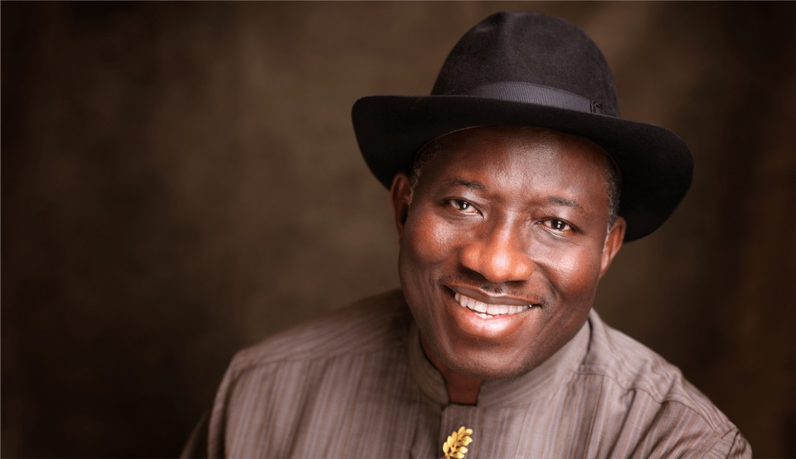

Former President (2010–2015), South-South leader, eligible for a single term due to a 2022 court ruling. His 2015 loss to Buhari was Nigeria’s first incumbent defeat.

**Strengths:**

**• National Appeal:** Jonathan’s presidency is viewed nostalgically by some, particularly in the South-South and Middle-Belt, for his inclusive governance and infrastructure projects (e.g., Almajiri schools). His 2024 PDP invitation reflects strong party support.

• **Northern Support:** Unlike other southern candidates, Jonathan has backing from northern groups wary of another Fulani candidate, giving him an edge in the North-West and North-Central.

• **Experience:** His prior presidency offers proven executive experience, appealing to voters seeking stability in a crisis-ridden economy.

**Weaknesses:**

**• 2015 Baggage:** Jonathan’s defeat was tied to perceived weak leadership on security (e.g., Boko Haram) and corruption scandals, which opponents may revive.

• **Hesitation:** Reports suggest Jonathan is reluctant to run, which could weaken his campaign momentum and party cohesion if he delays a decision.

• **Regional Competition:** His South-South candidacy may split southern votes with Obi or Amaechi, complicating PDP’s strategy against Tinubu’s APC.

**3. Atiku Abubakar (ADC/PDP)Profile:**

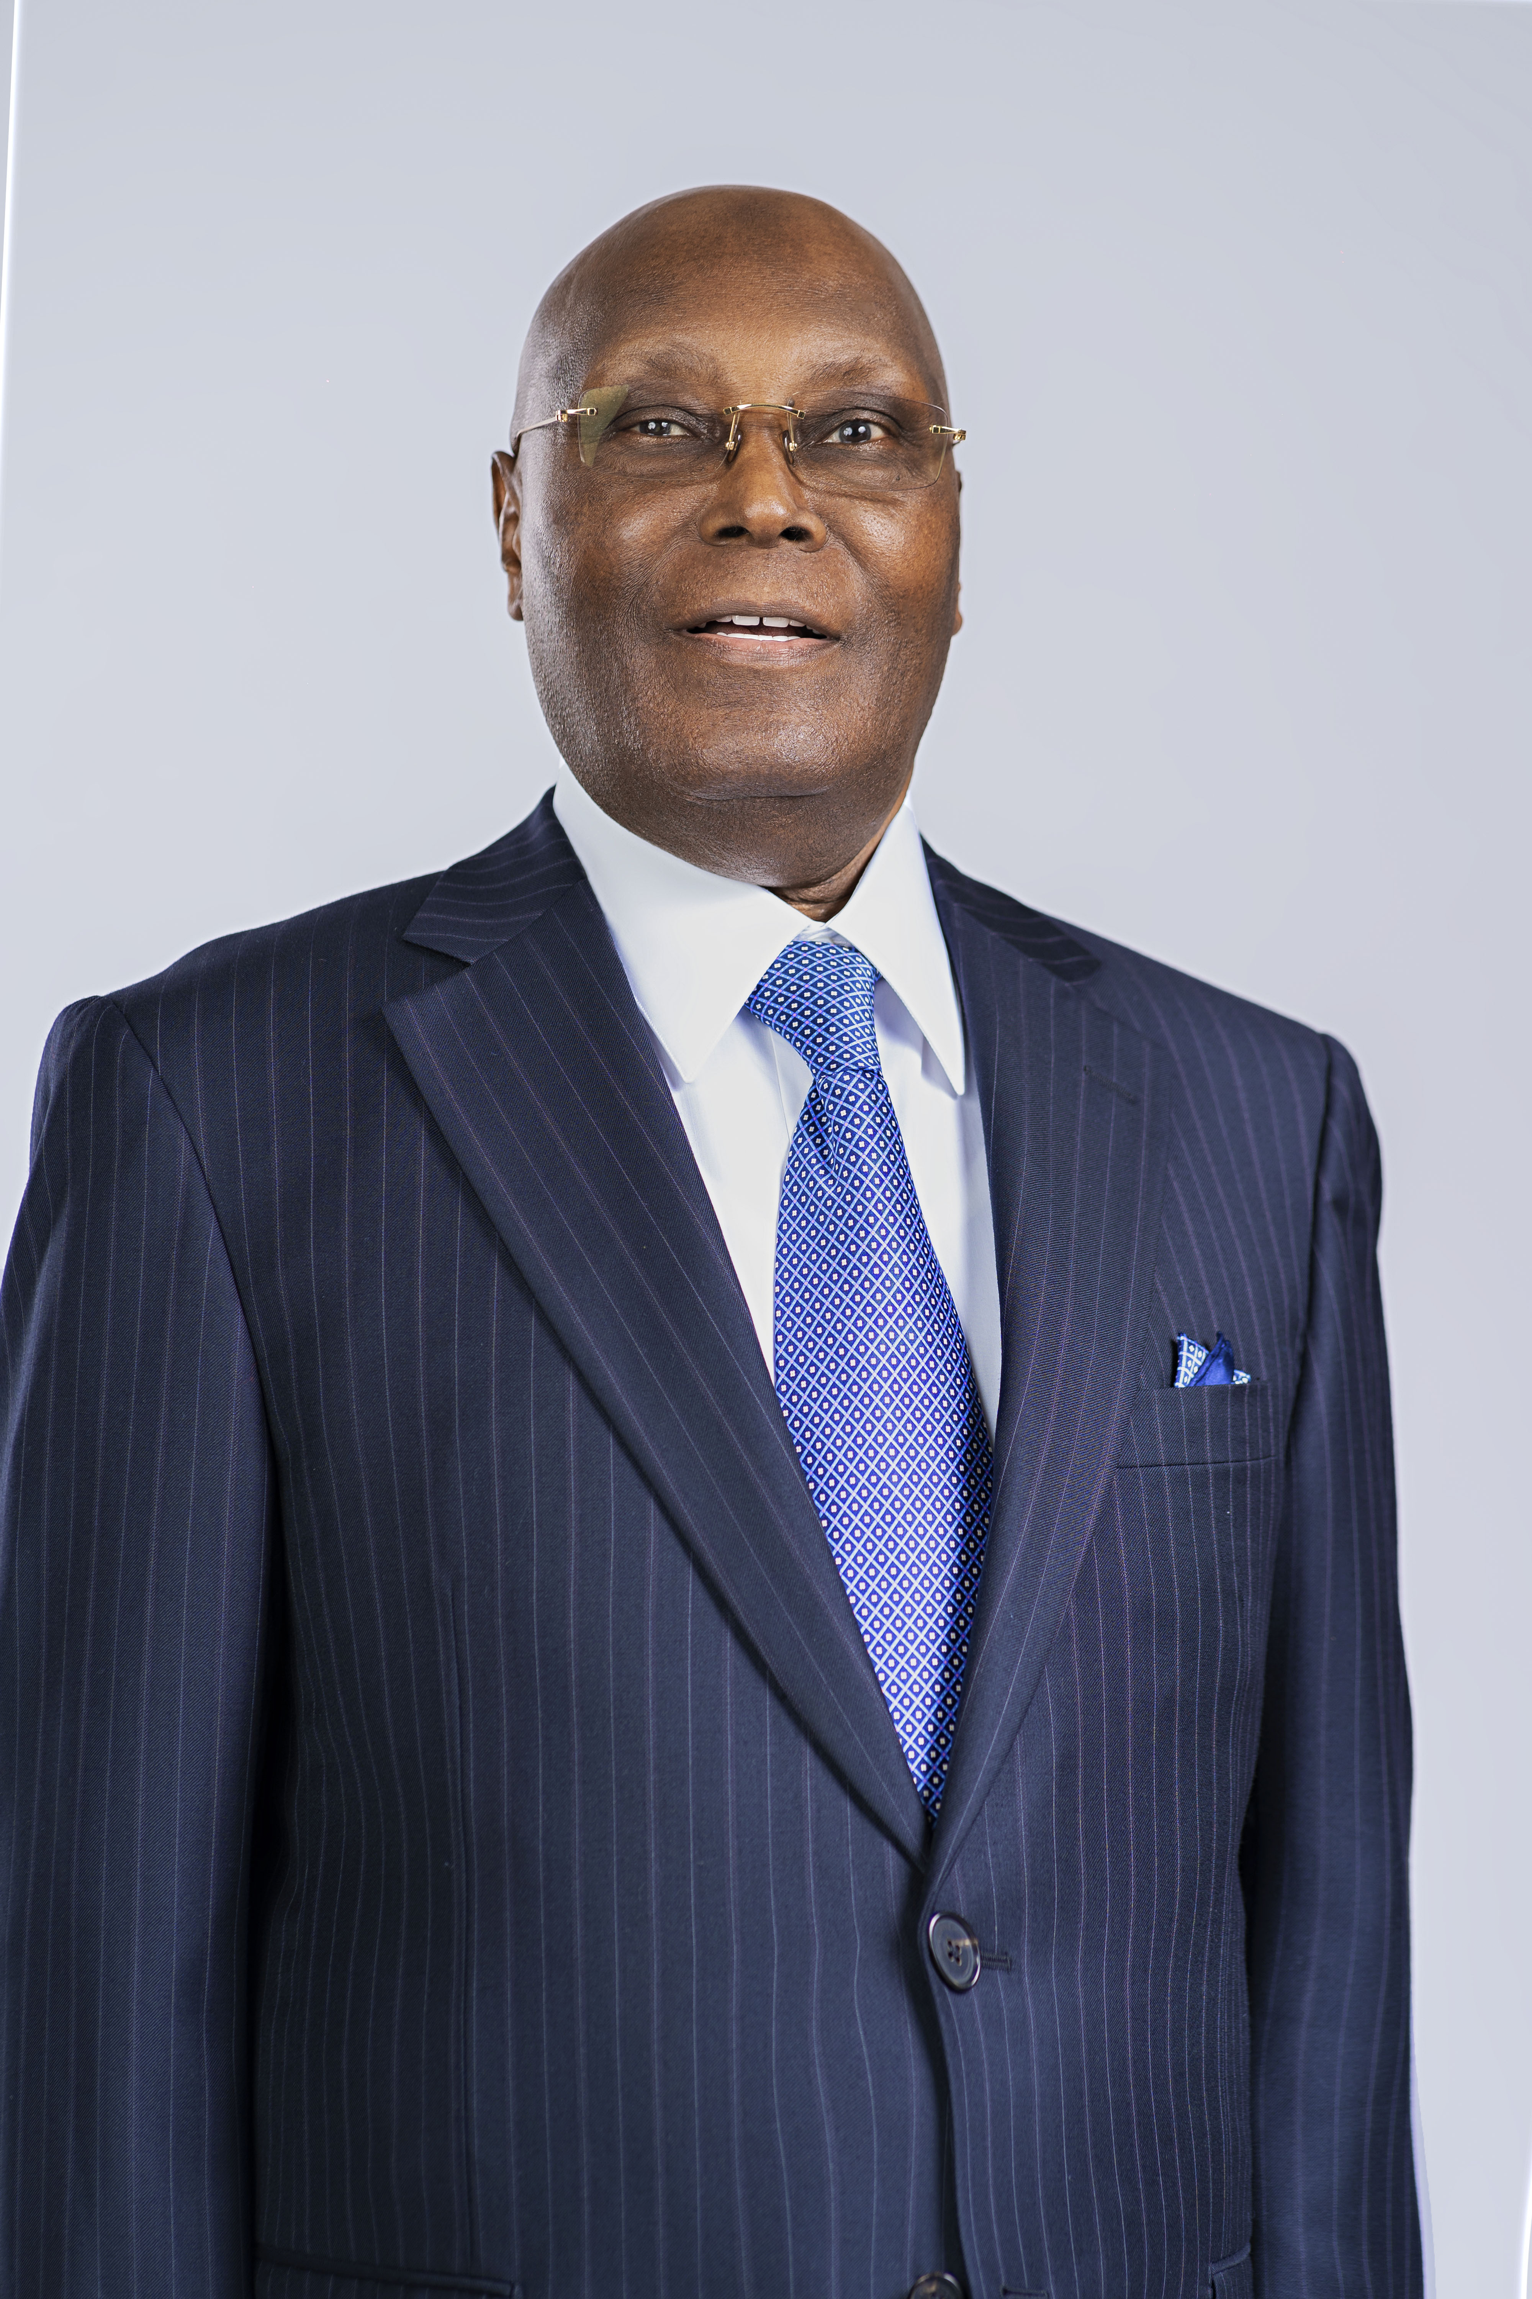

Former Vice President (1999–2007), six-time presidential candidate, and 2023 PDP runner-up (6.98 million votes). Recently joined the ADC coalition with Obi.

**Strengths:**

**National Reach:** Atiku’s PDP tenure and business empire give him a broad network across all six geopolitical zones, with a strong North-East base. His 2023 performance showed resilience.

**Coalition Strategy:** His leadership in the ADC coalition with Obi, El-Rufai, and others signals a unified opposition, potentially consolidating anti-APC votes.

**Policy Expertise:** Atiku’s “true federalism” platform resonates with regions seeking restructuring, particularly in the South-South and South-East.

**Weaknesses**

**Perceived Opportunism:** Atiku’s frequent party switches and repeated candidacies fuel perceptions of desperation, alienating younger voters and PDP stalwarts favoring a southern ticket.

**Northern Fatigue:** As a Fulani, Atiku faces resistance from voters wary of northern dominance after Buhari’s eight years, especially in the Middle-Belt and South.

**Coalition Tensions:** Rivalries with Obi and others in the ADC may fracture the alliance, as their competing ambitions lack a shared vision.

**4. Peter Obi (LP/ADC)Profile:**

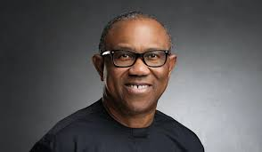  
Former Anambra Governor (2006–2014), 2023 LP candidate (6.1 million votes). Known for youth appeal and frugality, Obi is part of the ADC coalition.

**Strengths**

**Youth and Social Media Appeal:** Obi’s 2023 campaign galvanized Nigeria’s youth (39.7% of 2023 voters), particularly in the South-East and South-South, making him a social media phenomenon.

**Coalition Potential:** His ADC alliance with Atiku and others could unify opposition votes, with some X posts suggesting an Obi-El-Rufai ticket could challenge Tinubu.

**Clean Image:** Obi’s reputation for accountability and modest governance in Anambra contrasts with Nigeria’s corrupt political class, appealing to urban voters.

**Weaknesses**

**Limited Structure:** The LP’s weak national presence, especially in the North, limits Obi’s reach. His 2023 votes were concentrated in the South, and coalition disputes may dilute his base.

**Regional Perception:** Seen as an Igbo candidate, Obi struggles to win northern trust, especially if Jonathan runs, rendering his candidacy “inconsequential” per some analysts.

**One-Term Pledge:** Obi’s promise of a single term may deter voters seeking long-term stability, particularly in a coalition with Atiku’s longer ambitions.

**5. Rabiu Musa Kwankwaso (NNPP)Profile:**

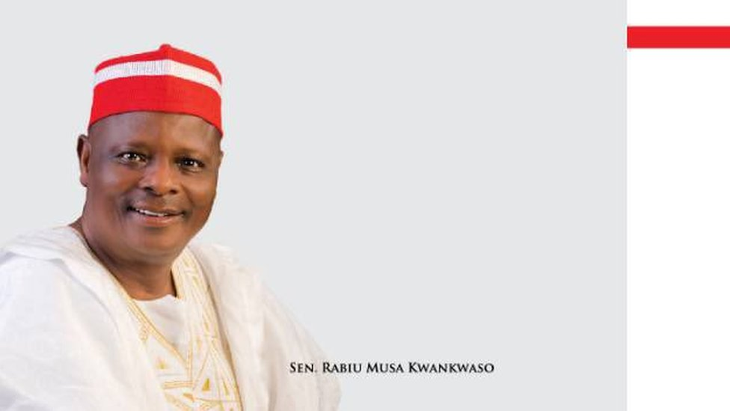

Former Kano Governor (1999–2003, 2011–2015), 2023 NNPP candidate (1.5 million votes). Leads the Kwankwasiyya movement with strong North-West influence.

**Strengths**

**Kano Stronghold:** Kwankwaso’s cult-like following in Kano, Nigeria’s vote-richest state, ensures significant ballots. His 2023 performance split northern votes.

**Grassroots Movement:**

The Kwankwasiyya’s 24 retired military officers and youth base bolster his regional clout, potentially extending to Jigawa and Katsina.

**Strategic Alliances:**

Talks of a South-West running mate could broaden his appeal, addressing his 2023 weakness outside the North-West.

**Weaknesses:**

Limited National Reach: Kwankwaso’s influence is confined to the North-West, with minimal traction in the South or North-Central, making him a regional rather than national contender.

**Coalition Absence:**

Unlike Atiku and Obi, Kwankwaso has not joined the ADC coalition, isolating him from broader opposition strategies.

**Security Critique:** His silence on northern security challenges (e.g., banditry) weakens his appeal in a region desperate for solutions.

**6. Seyi Makinde (PDP)Profile:**

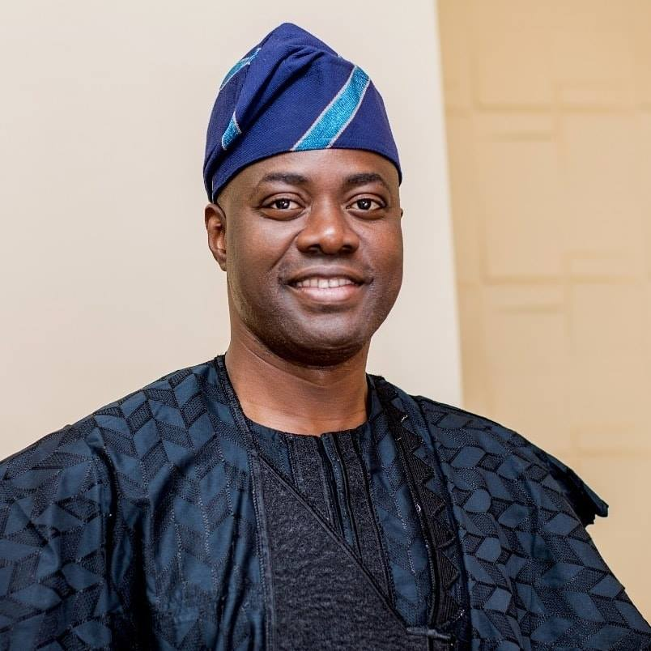

Current Oyo State Governor (2019–present), seen as a rising PDP star with strong South-West credentials and youth appeal.

**Strengths**

**Governance Record:** Makinde’s infrastructure and education reforms in Oyo have earned him praise as a competent administrator, appealing to voters seeking results.

**South-West Appeal:** As a Yoruba governor, he could challenge Tinubu’s regional dominance while bridging generational gaps with his relatively youthful image (60 by 2027).

**PDP Support:** PDP insiders view him as a viable southern candidate, aligning with the zoning formula, potentially unifying the party post-Atiku.

**Weaknesses**

**National Visibility:** Makinde lacks the national stature of Tinubu, Atiku, or Obi, limiting his recognition outside the South-West.

**Party Rivalries:** PDP’s internal crises, including Wike’s influence and Atiku’s ambitions, could sideline Makinde’s candidacy in primaries.

**Experience Gap:** Compared to former presidents or governors with longer national exposure, Makinde’s resume is relatively thin, risking perceptions of inexperience.

**7. Rotimi Amaechi (APC/Undecided)Profile:**

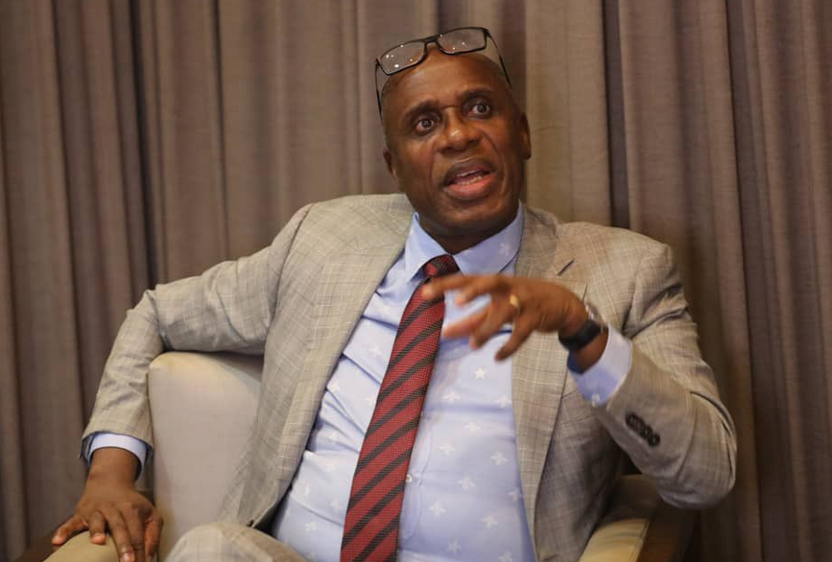

Former Rivers Governor (2007–2015) and Transportation Minister (2015–2023). Ran for APC’s 2023 nomination, losing to Tinubu.

**Strengths**

**South-South Base:** Amaechi’s Rivers State influence and South-South roots offer a regional counterweight to Tinubu and Jonathan, with potential cross-party appeal.

**Administrative Experience:** His tenure as governor and minister, overseeing projects like rail infrastructure, showcases competence, appealing to voters seeking delivery.

**Coalition Speculation:** Media reports suggest Amaechi could join the ADC or another platform, potentially pairing with a northern candidate like El-Rufai.

**Weaknesses**

**Party Uncertainty:** Amaechi’s unclear alignment (APC or ADC) risks alienating loyalists and weakening his campaign structure. His 2023 APC loss diminished his party clout.

**Regional Competition:** He faces stiff competition from Jonathan and Obi in the South-South/South-East, limiting his southern vote share.

**Low Public Profile:** Compared to Obi’s youth appeal or Tinubu’s dominance, Amaechi lacks a strong public persona, reducing his national traction.

**Critical Context Electoral Dynamics:**

The 2027 election requires a candidate to secure a plurality of votes and 25% in 24 states/FCT, favoring those with broad regional appeal (e.g., Tinubu, Atiku, Jonathan). The ADC coalition’s success hinges on unity, but internal rivalries (Atiku vs. Obi) may fracture it.

Voter Sentiment: Economic hardship and distrust in the political class (90% in 2025 surveys) favor outsiders like Obi or Makinde but challenge incumbents like Tinubu. Low turnout (27% in 2023) underscores the need for grassroots mobilization.

Regional Voting: The North-West (Kano, Kaduna) and South-West (Lagos, Oyo) remain vote-heavy, giving Tinubu and Kwankwaso an edge, while Obi and Jonathan dominate the South-East/South-South.

This analysis reflects the fluid nature of 2027’s race, with primaries and coalitions still evolving. For your online poll, these seven contenders cover the major players, but include an “Other” option for emerging candidates like Bukola Saraki or Nasir El-Rufai.